Reddit

📘 Definition
# Source: ScreenShots Source: Provided by: [Persons Table -> ID Column: 1, Name_En Column: Motasem Essam] -> Tool: [Lightshot Program] -> From [Site: https://www.reddit.com/] on [5/2/2026]
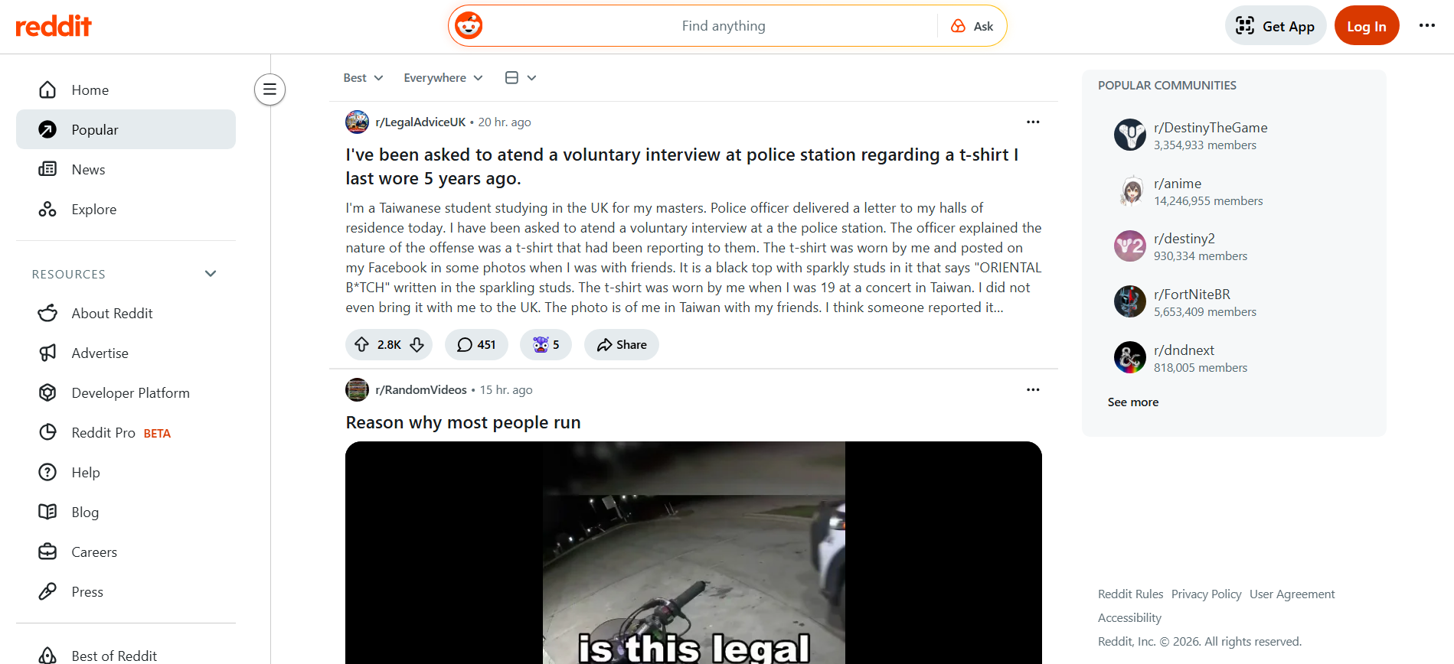
# Source: AI Source: Provided by: [Data Path: Persons Table -> ID Column: 1, Name_En Column: Motasem Essam] -> From: [ChatGPT] on [5/2/2026]
Reddit is a large online platform (a website and app) where people share posts, ask questions, and discuss topics in communities called subreddits.

🌐 How Reddit works
# Source: AI Source: Provided by: [Data Path: Persons Table -> ID Column: 1, Name_En Column: Motasem Essam] -> From: [ChatGPT] on [5/2/2026]
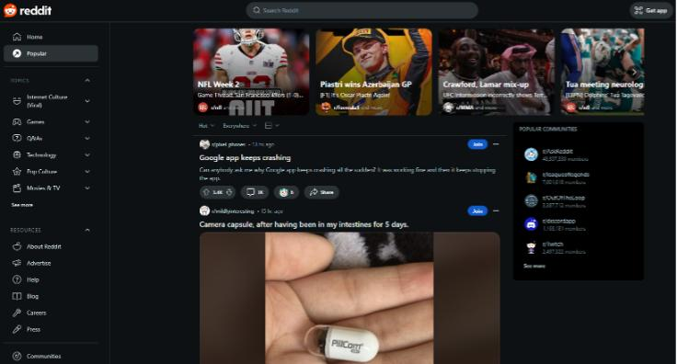
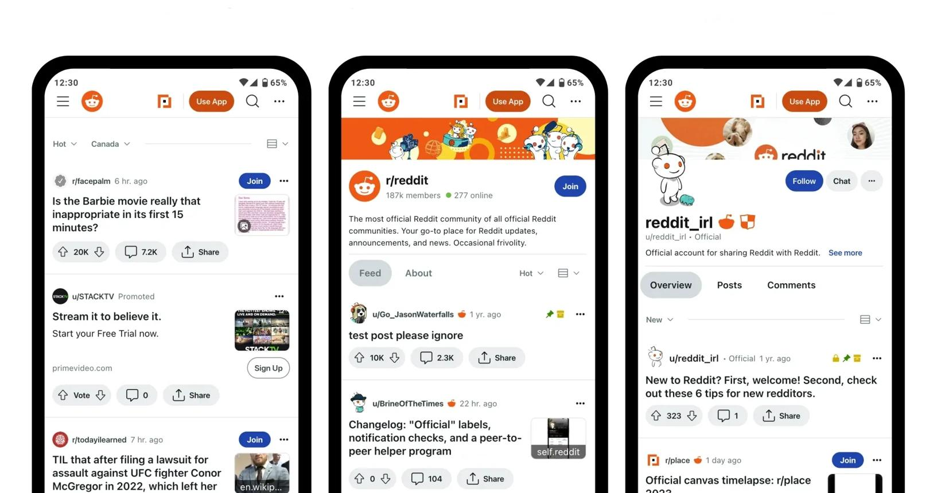
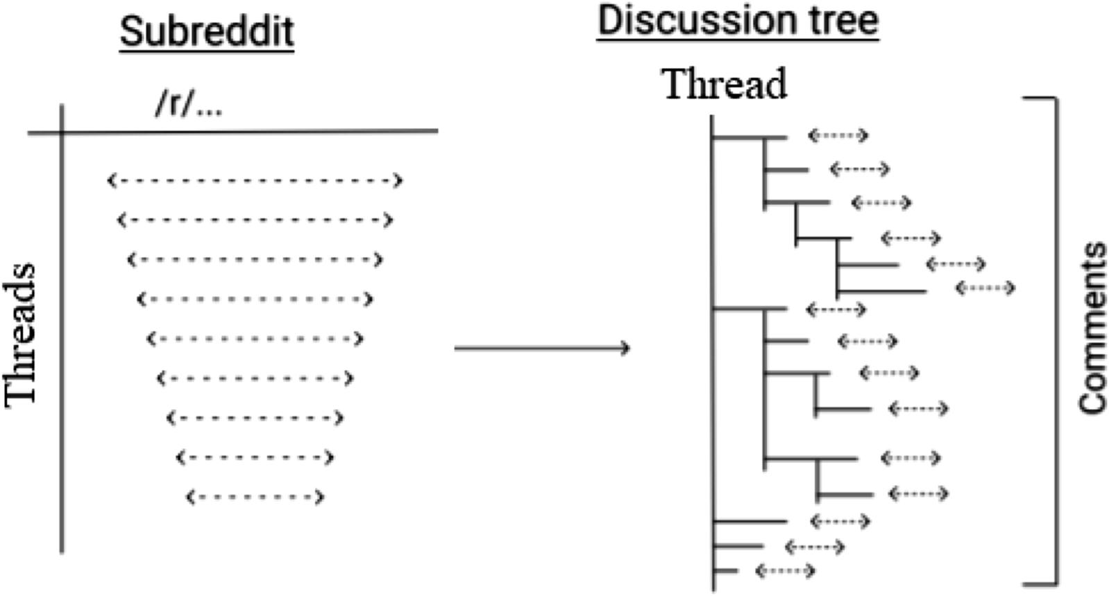
- Users post content like text, images, or links
- Other users upvote 👍 or downvote 👎 posts
- Posts with more upvotes become more visible
- Discussions happen in comment sections

🧠 What are Subreddits?
# Source: AI Source: Provided by: [Data Path: Persons Table -> ID Column: 1, Name_En Column: Motasem Essam] -> From: [ChatGPT] on [5/2/2026]
A subreddit is a community focused on a specific topic.
Examples:
- r/technology → tech news and discussions
- r/gaming → video games
- r/science → science topics
Each subreddit starts with “r/”

🎯 What people use Reddit for
# Source: AI Source: Provided by: [Data Path: Persons Table -> ID Column: 1, Name_En Column: Motasem Essam] -> From: [ChatGPT] on [5/2/2026]
- Asking questions and getting answers
- Sharing news and opinions
- Learning from communities
- Entertainment (memes, stories, discussions)

⚙️ Key features
# Source: AI Source: Provided by: [Data Path: Persons Table -> ID Column: 1, Name_En Column: Motasem Essam] -> From: [ChatGPT] on [5/2/2026]
- 👍 Upvote/downvote system
- 💬 Comment-based discussions
- 🧑‍🤝‍🧑 Topic-based communities (subreddits)
- 🔍 Wide range of topics (almost anything)

🚀 In short:
# Source: AI Source: Provided by: [Data Path: Persons Table -> ID Column: 1, Name_En Column: Motasem Essam] -> From: [ChatGPT] on [5/2/2026]
Reddit = a social discussion website made of communities where people share posts, ask questions, and vote on content.

